2007 Computer Vision Final Exam Solution
1.Please describe what is breakpoint optimization.
- after initial segmentation: shift breakpoints to produce better segmentation
- first: shift odd final point i.e. even beginning point
- then: shift even final point i.e. odd beginning point
2. Show the difference between nonrecursive and recursive neighborhood operator.
- nonrecursive neighborhood operators: output is function of input
- recursive neighborhood operators: output depends partly on previous output
3. What is the composition of thinning operator?
- thinning operator is composition of three operators: Yokoi connectivity, pair relationship, connected shrink
4. What is the characteristic of the result of the Relative Extrema Operator? Calculate the relative extrema for the following.
- relative extrema operators: relative maximum and minimum operators
- relative extrema: recursive operator, numeric data domain
- relative extrema: input not changed output successively modified top-down, left-right scan, then bottom-up, right-left scan until no change
- output value: of highest extrema reachable by monotonic path
- relative extrema pixels: output same as input pixels
9 | 6 | 6 | 6
9 | 9 | 6 | 6
9 | 9 | 9 | 6
9 | 9 | 9 | 9
5. Describe salt and pepper noise.
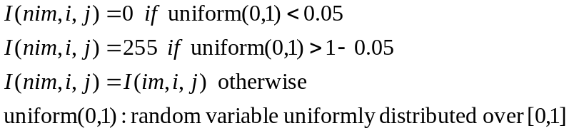

6. Describe S/N ratio.
- S/N ratio (signal to noise ratio):
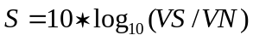

- VS: image gray level variance
- VN: noise variance
7. Describe Sobel edge detector.
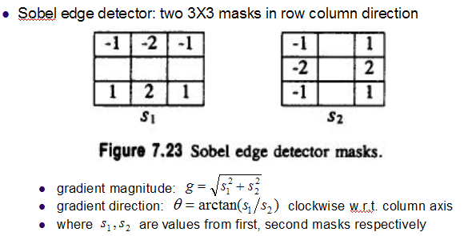
8. When index set is {-2,-1,0,1,2}, obtain its discrete orthogonal polynomial set.
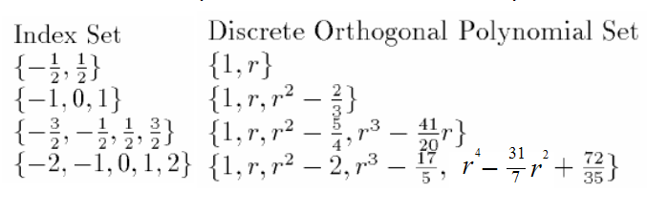
9. Describe five topographic structures.
peak, pit, ridge, valley, saddle, flat, hillside

10. What is the definition of Texture?
- Non-local property, characteristic of region larger than its size
- Repeating patterns of local variations in image intensity which are too fine to be distinguished as separated objects at the observed resolution
- For humans, texture is the abstraction of certain statistical homogeneities from a portion of the visual field that contains a quantity of information grossly in excess of the observer’s perceptual capacity
11. Please list the three texture analysis issues.
- Pattern recognition: given texture region, determine the class the region belongs to
- Generative model: given textured region, determine a description or model for it
- Texture segmentation: given image with many textured areas, determine boundaries
12. What is image segmentation?
- image segmentation: partition of image into set of non-overlapping regions
- image segmentation: union of segmented regions is the entire image
- segmentation purpose: to decompose image into meaningful parts to application
- segmentation based on valleys in gray level histogram into regions
13. Please describe the steps of recursive histogram-directed spatial clustering.
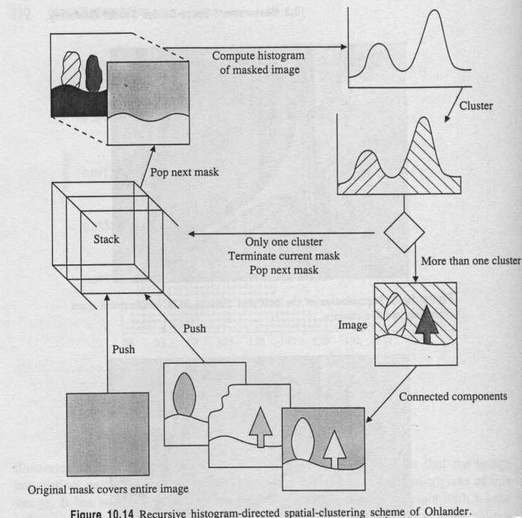

14. What is Hough transform?
- Hough transform: method for detecting straight lines and curves on images
- Hough transform: template matching
The Hough transform algorithm requires an accumulator array whose dimension corresponds to the number of unknown parameters in the equation of the family of curves being sought.

15. Please describe how to segment arcs into simple segment using tangential angle deflection.
- another approach: identify locations where two line segments meet
- exterior angle between two line segments: change in angular orientation
